**VOLLEYBALL**

1. **Introduction**
2. Team Sports; six players in each team separated by a net.
3. First played in the Olympics in Tokyo 1964.
4. Played majorly by hands; torso cannot be used; head can be used but very rarely.
5. Highest governing body:  Fédération Internationale de Volleyball(FIVB)
6. **History**
7. Played for first time in winters of 1895.
8. Played at Holyoke, Massachusetts; by physical education director at YMCA.
9. First Name: Mintonette.
10. First Rule Written by: William G. Morgan
11. Size of court: 25ftx50ft(7.6m x 15.2m) ; Height of net: 6ft 6in; Any no. Of players; composed of nine innings.
12. FIVB was founded in 1947.
13. **Types:**
14. Volleyball
15. Beach Volleyball(originated in Hawaii; year 1915)
16. Snow Volleyball(originated in Europe; year 2008/2009)
17. **Equipments:**
18. Nets and Posts: Placed vertically above at the centre of court whose top is to be set at a height of 2.43m for men and 2.24m for women.

Height of net as per age:

Under 12 years: 2.00m

12 years – 14 years: 2.12m

14 years – 16 years: 2.24m

Net length: 8.5m length and 1m (+- 3cm) wide. Made of square mesh

Note: In official competitions, an 8 m net with smaller mesh and branding with the publishing may be provided.

1. Two bands: Two coloured bands, 5cm side bands and 1 m long, are fastened vertically to the net and placed directly above each side line.

1. Antennae: Flexible rod of length 1.8m long and 10 mm in diameter made of fibreglass or similar material. The top 80 cm of each antenna extends above the net is marked with 10 cm stripes.
2. Balls: Shall be spherical; made of flexible materials (leather, synthetic or similar materials), which does not absorb moisture in any format. Must have a bladder inside made of rubber or a similar material. Colour: light uniform or a combination of colour. Circumference; 66 to 68 cm. Weight: 260 to 280 gm.

Inside pressure (for beach volleyball): 0.175 to 0.225 kg/cm2.

Inside pressure (for volleyball): 0.30 to 0.325 kg/cm2.

Inside pressure (for snow volleyball): 0.30 to 0.325 kg/cm2.

1. **Diagram:**
2. **Playing Court:**

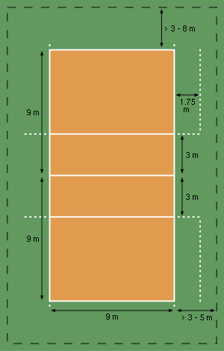

1. **Design of net:**

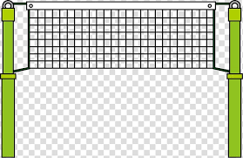

1. **Hand Direction:**

https://www.fivb.com/-/media/fivb/refereeingrules/pdf/volleyballhandssignal/fivb-volleyball_hand-signals_2017_2010-poster-en-v04.pdf?la=en